**GIT: Northeastern Spain**

Madrid · Zaragoza · Barcelona · Valencia

|  |  |  |  |
| --- | --- | --- | --- |
| http://cdn2.hubspot.net/hubfs/494840/DCN/3._La_Puerta_de_Alcala.jpg |  | http://fusterapartments.com/blog/wp-content/uploads/2015/06/la-sagrada-familia-wallpaper.jpg |  |

**day 1 Madrid**

English speaking assistance upon arrival at **Madrid** airport.

**transfer** to the hotel in the city.

leisure time in Madrid, enjoy the city, especially during the night, the bars, the cafes.

overnight at hotel in Madrid.

**day 2 Madrid**

breakfast at the hotel.

half day **Madrid** **sightseeing.**

*this half-day visit offers a complete tour of the history and architecture of the city of Madrid. tour starts in the old quarters of Madrid and ends in the modern business area, in the following itinerary: Puerta de Alcalá, Cibeles, Puerta del Sol, Calle Mayor, Plaza de la Villa, Plaza Mayor, Carrera de San Jerónimo, Calle Atocha, Reina Sofia museum, Atocha main railway station, Ministry of Agriculture, Prado museum, Banco de España, Paseo de la Castellana, Bernabéu football stadium.*

overnight at hotel in Madrid.

**day 3 Madrid - Zaragoza**

breakfast at the hotel and check out.

**transfer** to **Zaragoza**.

half day **Zaragoza** **sightseeing.**

*you will find a stunning legacy of monuments in the streets of the city, vestiges of the Roman, Moorish, Jewish and Christian Roman ruins such as the Circus; Aljafería Palace; Mudejar-style churches…*

overnight at hotel in Zaragoza.

**day 4 Zaragoza - Barcelona**

breakfast at the hotel and check out.

**transfer** to **Barcelona**.

leisure time in **Barcelona**, enjoy the weather and cuisine in Barcelona. shopping could be your first option in Barcelona or watch a football match.

overnight at hotel in Barcelona.

**day 5 Barcelona**

breakfast at the hotel.

half day **Barcelona sightseeing.**

*discover Barcelona with a general approach to its main tourist sights. a basic but complete itinerary will help you get to know the city by covering the most interesting places from the artistic and cultural point of view: the Gothic Cathedral, Plaça Catalunya, Passeig de Gràcia, Sagrada Familia.*

overnight at hotel in Barcelona

**day 6 Barcelona - Valencia**

breakfast at the hotel and check out.

**transfer** to **Valencia**.

half day in the **Oceanographic** of Valencia within City of Arts & Sciences.

*the Oceanographic of the City of Arts and Sciences is the largest aquarium in Europe and contains representatives of the world’s main marine ecosystems.*

overnight at hotel in Valencia.

**day 7 Valencia - Madrid**

breakfast at the hotel and check out.

**transfer** to **Madrid**.

leisure time, enjoy the afternoon in the city. you can watch a football match in Santiago Bernabeu or go shopping.

overnight at hotel in Madrid.

**day 8 Madrid**

breakfast at the hotel and check out.

**transfer** to the airport of Madrid.

**end of services**

**prices**

|  |  |  |  |  |  |  |
| --- | --- | --- | --- | --- | --- | --- |
| **package price per person** | **Nov - Mar** | | **Apr - Oct** | | **Jul - Aug** | |
| **standard class *hotels in Madrid, Barcelona and Valencia located in outskirts** | **pax** | **€** | **pax** | **€** | **pax** | **€** |
| **15-19** | 623 | **15-19** | 687 | **15-19** | 666 |
| **20-24** | 536 | **20-24** | 598 | **20-24** | 578 |
| **25-29** | 484 | **25-29** | 545 | **25-29** | 524 |
| **30-39** | 459 | **30-39** | 519 | **30-39** | 499 |
| **40-49** | 414 | **40-49** | 472 | **40-49** | 452 |
| **single suppl.** | **197 €** | | **215 €** | | **223 €** | |
| **half board suppl.** | **111 €** | | | | | |
| **first class  *hotel in Barcelona located in outskirts** | **pax** | **€** | **pax** | **€** | **pax** | **€** |
| **15-19** | 684 | **15-19** | 839 | **15-19** | 815 |
| **20-24** | 594 | **20-24** | 742 | **20-24** | 718 |
| **25-29** | 541 | **25-29** | 684 | **25-29** | 661 |
| **30-39** | 515 | **30-39** | 655 | **30-39** | 632 |
| **40-49** | 467 | **40-49** | 604 | **40-49** | 582 |
| **single suppl.** | **234 €** | | **334 €** | | **318 €** | |
| **half board suppl.** | **171 €** | | | | | |
| **superior class *hotel in Barcelona located in outskirts** | **pax** | **€** | **pax** | **€** | **pax** | **€** |
| **15-19** | 915 | **15-19** | 1.095 | **15-19** | 995 |
| **20-24** | 816 | **20-24** | 988 | **20-24** | 892 |
| **25-29** | 756 | **25-29** | 923 | **25-29** | 830 |
| **30-39** | 726 | **30-39** | 890 | **30-39** | 799 |
| **40-49** | 674 | **40-49** | 834 | **40-49** | 745 |
| **single suppl.** | **388 €** | | **506 €** | | **441 €** | |
| **half board suppl.** | **244 €** | | | | | |

* prices per person based on double room & bb basis. taxes included. minimum 15pax, maximum 49pax.

* one person in single room free of charge.

* prices subject to availability and possible fluctuations in any of the requested services at the time of final booking.

**validity**: **until October 2020.**

**inclusions:**

|  |  |  |  |  |
| --- | --- | --- | --- | --- |
| **city & nights** | **transfers** | **sightseeing** | **meals** | **24h phone**  **assistance** |
| **3n Madrid** | by coach | half day Madrid city tour | breakfast |
| **1n Zaragoza** | half day Zaragoza city tour | breakfast |
| **2n Barcelona** | half day Barcelona city tour | breakfast |
| **1n Valencia** | half day visit to Oceanographic in Valencia (including entrance fee) | breakfast |

* one person free of charge.

**prices do not include:**

* regional tourist tax.
* flight tickets.
* tips and guests´ extras.
* supplement for extra language (Russian, French, German, Chinese…).
* any other service not mentioned on the programme / itinerary described.

**itinerary & number of nights**

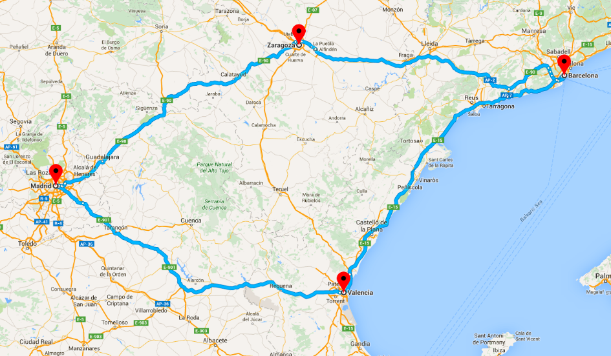

**3n**

**Madrid**

**2n**

**Barcelona**

**1n**

**Valencia**

**1n**

**Zaragoza**